**Deliverable**

**Lab Deliverable 3**

## 1. Please keep 3 different types of places you’ve created in the Lab Prep 3 and use them. If you don’t keep them in your Gimbal account, you can import them from your csv file that you’ve submitted on Lab Prep 3.

|  |  |  |  |
| --- | --- | --- | --- |
| Places | Place Name | Geofence | Beacons |
| No 1 | YourLastName_YourBeaconName |  | Your Beacon |
| No 2 | YourLastName_AVW | AVW Building either with minimum radial or exact boundary with polygonal |  |
| No 3 | YourLastName_YourBeaconName_AVW | AVW Building either with minimum radial or exact boundary with polygonal | Your Beacon |

Create Communication as follows for those 3 places you’ve created. (10 pts)

|  |  |  |  |  |
| --- | --- | --- | --- | --- |
| Communications | Name | Start & End Date | Place | Notification Title |
| No 1 | YourLastName_YourBeaconName_Arrival | 2019/3/25 ~ 2019/4/7 | YourLastName_YourBeaconName | Arrived at YourBeaconName |
| No 2 | YourLastName_YourBeaconName_Departure | 2019/3/25 ~ 2019/4/7 | YourLastName_YourBeaconName | Left from YourBeaconName |
| No 3 | YourLastName_AVW_Arrival | 2019/3/25 ~ 2019/4/7 | YourLastName_AVW | Arrived at AVW |
| No 4 | YourLastName_AVW_Departure | 2019/3/25 ~ 2019/4/7 | YourLastName_AVW | Left from AVW |
| No 5 | YourLastName_YourBeaconName_AVW_Arrival | 2019/3/25 ~ 2019/4/7 | YourLastName_YourBeaconName_AVW | Arrived at your 3’rd place |
| No 6 | YourLastName_YourBeaconName_AVW_Departure | 2019/3/25 ~ 2019/4/7 | YourLastName_YourBeaconName_AVW | Left from your 3’rd place |

### ***\*\* Please make sure to remove the beacon from your list once you’re done with it at the end of the day, so that others can use it! (This is very important!!!)***

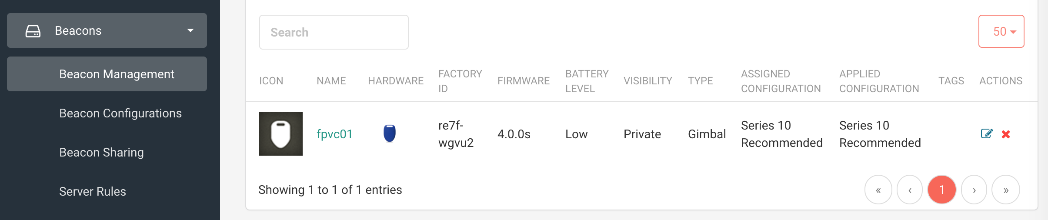

## 2. Follow the Lab 3-2 (1 ~ 7) and run your application associated with your Beacon, your Places, and your Communications. Do these experiments and report your results as described below. (10 pts)

Move around to get in and out of 3 places so that your app receives all the communications and those records are displayed on the screen. Copy and paste the screenshots of those records from the screen.

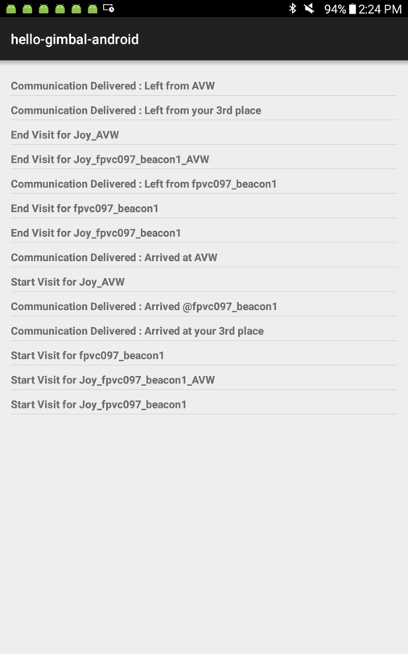

Measure the delay of the message and measure how far the beacon reaches.

**The beacon relayed a notification to my device once I reached as far as the bridge to CSIC from AV Williams.**

Measure the geofence and region boundary. How accurate is it?

**The geofence/region boundary is not too accurate. With a region around AV Williams, the notification leaving the region occurred once I left CSIC just before entering Iribe.**

Do experiment and verify the No. 3 place in 1 and see how it works. Explain it here with how you do experiment and its result.

**The third location worked when I left both the geofence region and the beacon.**

### ***\*\* Please make sure to remove the beacon from your list once you’re done with it at the end of the day, so that others can use it! (This is very important!!!)***



## 3. Submit your Analytics data. (10 pts)

Check the dashboard from the menu ‘Analytics’ on Gimbal Manager.

Submit these 3 files together with your submission.

* Place_visits.csv
* Communicate_events.csv
* Beacon_status.csv

On Monday, come back to this and download them again, attach as comments to your submission.

Most analytic data will be collected after 24 hours. So, your attachment on Monday should include all of your activities including Friday.

### ***\*\* Please make sure to remove the beacon from your list once you’re done with it at the end of the day, so that others can use it! (This is very important!!!)***



## 4. How can Beacon improve indoor navigation? Do some research and explain how it works. You may need to study and understand RSSI. Provide examples and references you’ve found. (5 pts)

## We’ve tried a sample from Gimbal using Gimbal format (Gimbal configuration type). What would be strength and challenges/limits when we use this for museum visitors? Eddystone is another open beacon format for google/iOS Nearby Messages API which can replace Gimbal format for Gimbal applications. Do some research and compare this with Gimbal in terms of each one’s strength and challenges/limits for your research. (5 pts)

## **Beacon can improve indoor navigation technology by enabling free, easy, and relatively accurate location intelligence for developers creating navigation technology. Beacons themselves are small and inexpensive and a vast array of beacons can create a network of locations/checkpoints which is ideal for implementation in an indoor setting. Beacons work by using Bluetooth low energy technology (BLE). These signals are transmitted to your phone which in turn transmits this data and receives data from the Gimbal cloud server. Your smart phone’s built in GPS capabilities provide information on where YOU the user is. Specifying an RSSI is crucial in determining when Gimbal considers you within or out of a location or region. RSSI stands for Received signal strength indication. It is a measure of the signal strength of a beacon. Setting a specific RSSI for Arrival would tell Gimbal that you have arrived at that location when that specific RSSI is detected. RSSI signals below that level are ignored. The same applies for departure.**

**When using this for museum visitors, visitors could possibly be able to navigate the museum with relative accuracy. Eddystone is developed by Google and is an alternative beacon format released in 2015. Eddystone is used more for one time applications and for enabling brand recognition when used in conjunction with services such as Android Nearby.**

**Reference: https://www.beaconstac.com/ibeacon-and-eddystone**

### ***\*\* Please make sure to remove the beacon from your list once you’re done with it at the end of the day, so that others can use it! (This is very important!!!)***



## 5. Set up for “8. Instant Communications” from Lab 3-2 and send Instant Push (10 pts)

## Do some experiment and copy & paste of your results here with your written report.

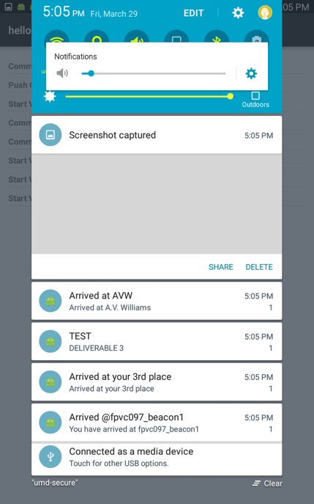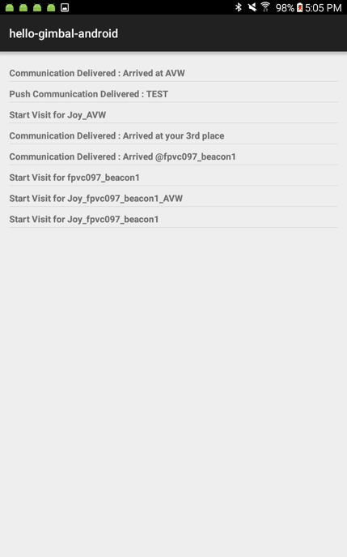

**After signing up for Firebase with my Google account, I was able to link Firebase to my Beacon project in Android studio using a provided server key from Firebase. In addition to do doing this, I had to download required packages from the SDK Tools in the Package Manager within Android Studio. Once built and running, I created an instant Communicate message in my Gimbal Manager and published it as the app was running. This sent an instant push notification to the app. I also created a new Communicate message for a scheduled push notification and published it as well, which sent the push after the specified amount of time.**

**I found this push notification feature very interesting and possibly useful. Some applications for museums could be museum staff using instant push notifications to notify visitors of exciting news and events happening within the museum.**

### ***\*\* Please make sure to remove the beacon from your list once you’re done with it at the end of the day, so that others can use it! (This is very important!!!)***

